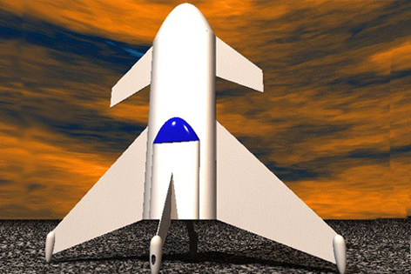

Spaceships Template
This vehicle is designed to be a totally private financed manned, reusable suborbital rocket.
Space CubDeveloperDavid L. BurkheadTypeSuborbitalNumber of Stages1Launch / LandingVertical / HorizontalPayload1 crew + 3 pax (245 km)Launch Mass18 MgPropulsion System3×RocketStatusActive, n.a. - Present, ConceptHomepagehttp://www.sff.net/people/dburkhead/spacecub.htmE-maildburkhead@sff.net
★☆☆☆☆

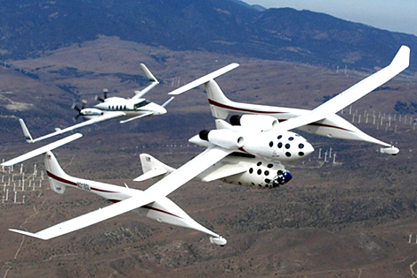

White Knight and SpaceShipOne have been realized and went through some flight tests. On June 21, 2004, SpaceShipOne reached space.
SpaceShipOne (Booster: White Knight)DeveloperScaled CompositesTypeSuborbitalNumber of Stages2 (PLN-r: 1, ORB-r: 1)Launch / LandingHorizontal / HorizontalPayload1 crew + 2 pax (115 km)Launch Mass7,7 Mg (White Knight: 4,1 Mg, SpaceShipOne: 3,6 Mg)Propulsion SystemWhite Knight: 2×Turbojet, SpaceShipOne: 1×RocketStatusActive, 1996 - Present, Realized (3 flights)Homepagehttp://www.scaled.comE-mailinfo@scaled.com
★★★★★

?
?Developer?Type?Number of Stages?Launch / Landing?Payload?Launch Mass?Propulsion System?Status?Homepage?E-mail?
★★★★★

?
?Developer?Type?Number of Stages?Launch / Landing?Payload?Launch Mass?Propulsion System?Status?Homepage?E-mail?
★☆☆☆☆

